CUSTOMER CARE

# REGISTRY

LITERATURE SURVEY

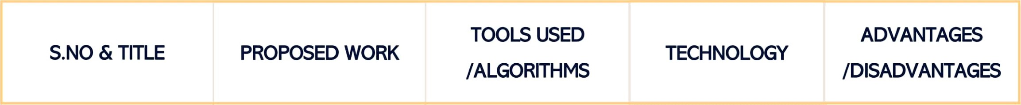This proposes a robust, scalable, and extensible architecture with a technology stack consisting of the EjabberdServer.

The Ejabberd server makes creates the roomfunctionality where the customer needs to be persistent over time in that room

|  |  |  |  |
| --- | --- | --- | --- |
| REAL WORLD SMART |  | AWS Public Cloud |  |
| CHATBOT FOR | This journal employ chatbot | AWS Lambda |  |
| CUSTOMER CARE | for customer care. This is | API Gateway | Cloud Computing |
| USING A SOFTWARE | done by providing a human | LUIS | Machine Learning |
| AS A SERVICE (SAAS) | way interaction using LUIS | Ejabberd |  |
| ARCHITECTURE | and cognitive services. | Chatbot |  |

4

Literature survey

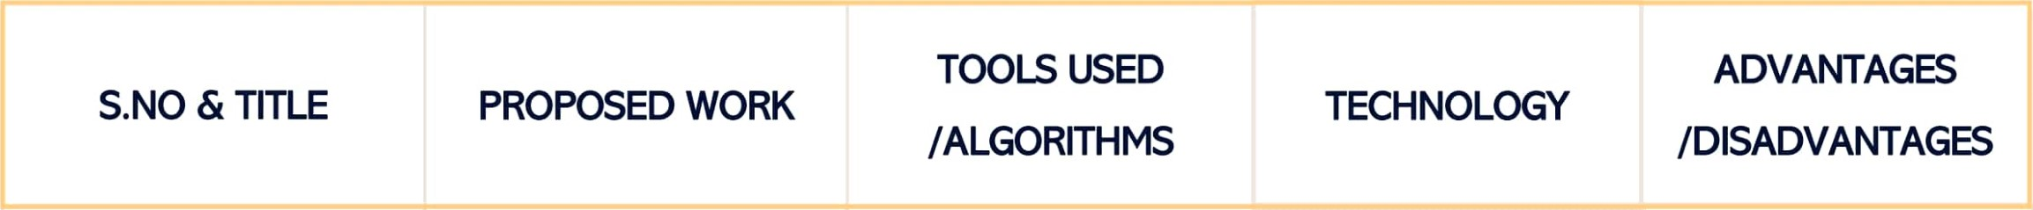

|  |  |  |  |  |  |
| --- | --- | --- | --- | --- | --- |
| AN INTELLIGENT CLOUD BASED | This paper proposes that the customer are |  |  |  |  |
| CUSTOMER | categorized based on | • | Intelligent Cloud- | Cloud | Customer care is given |
| RELATIONSHIP | purchase behaviours, |  | based Customer | Computing | based upon purchase |
| MANAGEMENT | historical ordering patterns |  | Relationship | Artificial | behaviours, features of the |
| SYSTEM TO | and frequency of purchase |  | Management | Intelligence | product purchased without |
| DETERMINE  FLEXIBLE PRICING  FOR CUSTOMER  RETENTION | customize customer care and promotions are given. |  |  |  | any interaction.  5 |

Literature survey

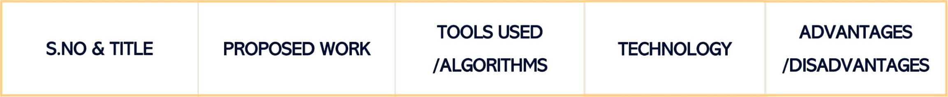

In this paper customer trust

|  |  |  |  |  |  |  |  |  |  |  |
| --- | --- | --- | --- | --- | --- | --- | --- | --- | --- | --- |
|  | | chatbots to provide the | | Chatbot | | • Cloud Computing | | | This provides automated | |
| CHATBOT FOR | | required support. Chatbots | |  | | • Artificial Intelligence | | | customer service with the | |
| CUSTOMER SERVICE  Literature survey | | represent a potential means for automating customer service. | | Java Script | | • Machine Learning | | | use of the cloud.  6 | |
|  | customer care registry | | Chatbots | | Cloud | | | 1. Maintain Flexibility | |
| ARTIFICIAL | using Artificial intelligence. | |  | | Computing | | | and focus on their | |
| INTELLIGENCE | This assists consumers in | | Python | | Artificial | | | customers. | |
| REPLACING HUMAN | decision making. Based on | |  | | Intelligence | | | 2. The use of chatbots | |
| CUSTOMER SERVICE | the computers-are- social- | | Mongo DB | |  | | Machine | in service interactions may | |
|  | actors paradigm | |  | | Learning | |  | raise greater consumer concerns regarding privacy risk issues.  7 | |

Literature survey

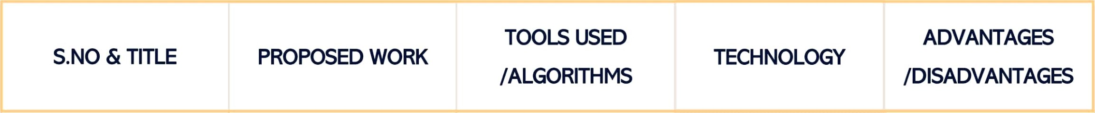

This journal Chatbots for

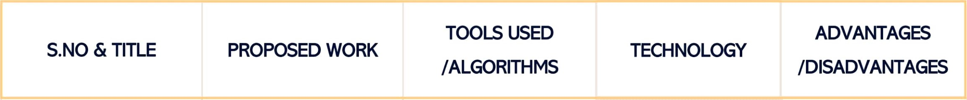8

|  |  |  |  |  |
| --- | --- | --- | --- | --- |
|  | In this paper, we employ the software as a service |  |  | Feedback loops are used that allow the service provider to capture feedback at the point of |
|  | (SaaS) model which introduces drastic | Java Script |  | experience. One way to find out is to conduct continual |
| IMPLEMENTING | improvement to the | HTML | Cloud Computing | end-user experience |
| CONTINUOUS | situation, as the service |  | Machine Learning | monitoring to determine if |
| CUSTOMER CARE | provider can now have direct access to the user data and analyze it if agreed appropriately with the customer. | Google Analytics |  | users are happy  2. It is not always easy for SaaS providers to know what customers are experiencing. |

Literature survey



# Thank you